Contents

Introduction 1

Parts and Tools List – About $135 Excluding Frame 2

Comments re Parts/Tools/Process 3

Setting Up the Raspberry Pi 5

Solder the Header Pins to the Pi 5

Operating System Installation 5

Installing Software Pre-Requisites 6

Install Without OLED Display 6

Install With OLED Display Support 7

Copy Application Files to Pi 8

Connecting the LED String to the Pi 9

Testing the LEDs 10

Configure Application for First Run 11

GO! 12

Scheduling of Metar Updates and “Lights Off” Time 12

“Animation” for Wind and/or Lightning, and Blinking vs Fading 13

Observations on LED Colors 13

Powering Down the Pi 13

Getting Your Map Printed 14

Optional Color LED Metar Display 15

Optional displayairports File 15

Wire Up Your Display 15

Testing the Display 16

Modified displaymetar.py Script for Alternate Display Text 17

Construction – Finally! 18

Alternate Build with WS2812B Flat LEDs 22

Edit metar.py Script 23

# Introduction

This project was made possible by software and documentation created by Philip Rueker:

<https://slingtsi.rueker.com/making-a-led-powered-metar-map-for-your-wall/>

<https://github.com/prueker/METARMap>

Refer to those sources for a full description, his parts list, pictures, user comments, etc. The installation instructions on github are out of date and won’t work today. Use the instructions herein. The good news is Philip’s software continues to shine.

I forked a copy of Philip’s GitHub project, to house a copy of this document .

<https://github.com/jcl-rv12is/METARMap>

After I started implementing this project, I researched several other METAR map apps and hardware solutions. There are options out there, but this software is simple to set up and operate and is the most complete and flexible that I’ve found.

This document covers only the specific process used in our specific map build projects. Your mileage may vary.

# Parts and Tools List – About $135 Excluding Frame

*The links, products and prices are accurate as of the date of this document.*

*For a map that has less physical depth, you can substitute flat WS2812B LEDs (#10 below) vs the bullet style LEDs (#9 below) in this parts list. See the* ***Alternate Type of Build*** *section later in this document for some additional comments.*

1. Pi Zero W Kit with pre-soldered header, $41.99

<https://vilros.com/products/raspberry-pi-zero-w-basic-starter-kit-1?variant=39984865869918>

1. 16gb MicroSD Card w/Carrier, $10.00

<https://www.amazon.com/SanDisk-Ultra-Micro-Adapter-SDSQUNC-016G-GN6MA/dp/B010Q57SEE/ref=sr_1_4?crid=1FRDKVJACU9MC&keywords=16gb%2Bmicro%2Bsd%2Bcard&qid=1697998180&sprefix=16gb%2Bmicro%2Bsd%2Bcard%2Caps%2C325&sr=8-4>

1. OLED Display, $6.99, optional

<https://www.amazon.com/dp/B072Q2X2LL?psc=1&ref=ppx_yo2ov_dt_b_product_details>

1. Elmer’s Foam Board, White, 16x20, 3 pack, $7.99, only 2 required (1 for the flat LEDs)

<https://www.michaels.com/elmers-foam-boards-16inx20in-3ct/10185631.html>

1. Velcro Strips, $5.99, used to affix the Pi to the back of the map assembly. Optional.

<https://www.michaels.com/velcro-brand-sticky-back-strips/M10044676.html?dwvar_M10044676_count=4>

1. Gorilla Spray Adhesive, $12.99

<https://www.michaels.com/gorilla-spray-adhesive/10633585.html>

1. Adhesive Poster 16x20 Print of Sectional, $24.99, OfficeMax

Details are given later in this document. We will not be using the adhesive that is on this print. Rather, we ordered the adhesive backed version just for the additional stiffness it adds to the print.

1. Jumper Wires, $6.98

<https://www.amazon.com/dp/B01EV70C78?ref=ppx_yo2ov_dt_b_product_details&th=1>

If not using the OLED display, you only need 3 male to female jumpers. For the OLED display, you’ll also need 4 female to female jumpers.

1. WS2811 (bullet style) LED Light String, $15.50

<https://www.amazon.com/gp/product/B01AG923GI/ref=as_li_ss_tl?ie=UTF8&linkCode=sl1&tag=slingtsirueke-20&linkId=35c4b586c1ae4a9e42668aa3cf6920bd&language=en_US&th=1>

1. If you choose to use the flat WS2812B LEDs, get these instead of the above WS2811 LEDs. Delivery time for these can be two weeks plus.

WS2812B DC5V 22mm diameter round pixel light,DC5V input(5050 smd RGB led with WS2811IC built-in), $7 plus shipping, string of 50 lights

<https://www.aliexpress.us/item/2251800954774376.html?spm=a2g0o.productlist.main.1.68514279T2cK79&algo_pvid=3e9a60ca-4888-4a41-a6f8-6557a5605f99&algo_exp_id=3e9a60ca-4888-4a41-a6f8-6557a5605f99-0&pdp_npi=3%40dis%21USD%217.0%217.0%21%21%21%21%21%40211bea0816834691617383051d07b9%2112630401719%21sea%21US%214563208766&curPageLogUid=1l6QVXirsdB5>

1. Mini glue gun and glue sticks (you’ll go thru several sticks for the lights in #9, less for #10)
2. Soldering iron, solder, solder sucker. This is needed for two things – first, if your Pi does not have a pre-soldered header, and second, to clean up and round out the punched holes on the front of the map.
3. 1/8” center punch
4. 1/8” and 9/32” drill bits
5. Drill
6. 4 medium bull dog clips
7. Black duck/electrical tape
8. Push pins
9. 4 index cards or something similar
10. Laptop or PC w/MS Windows
11. HDMI monitor and keyboard to be connected to Pi during installation

## Comments re Parts/Tools/Process

1. The OLED screen is optional. The display is small, and the default text is tiny. The display is unreadable from even a few feet away. An alternate python script to use larger text (but less information) is embedded later in this document.
2. Other Raspberry Pi models can be substituted. We have successfully used a Pi 3 B+ and Pi 2B V1.1 w/a wifi dongle.
3. A short video on soldering the header pin block to the Pi is here. Do yourself a favor and get a Pi with the pins already soldered.

<https://www.youtube.com/watch?v=8Z-2wPWGnqE>

1. An 8gb MicroSD card would do fine vs 16gb, but the read/write speed of those older gen smaller capacity cards is slow compared to larger capacity cards. That speed only matters when setting up the Pi initially. 32gb cards are the same price as 16gb lately, but I’ve had two 32gb cards get corrupted for some reason, so I shy away from them.
2. Be sure to have a fine nib for your soldering iron if soldering the header block onto the Pi. For the optional step of rounding out the punched holes from the front of the map, you’ll want a flat or round nib.
3. You MUST use the Raspberry imaging tool, and for consistent results MUST setup ssh, an id/password, and Wi-Fi networking from within the imaging tool. Further, the only good result came after deleting any existing volumes on the microSD card. Simply writing/rewriting the image in many cases DID NOT work unless all volumes were wiped out before starting. If you follow the instructions in this document, you’ll be fine.
4. During setup, you may find it helpful to have a separate HDMI monitor and keyboard for use with the Pi in addition to whatever monitor and keyboard you have for your PC, so you can run commands on each without disconnecting and reconnecting hardware. In the alternative, you can ssh into the Pi from your PC.
5. If you ever move your unit to a different wireless network, plug in a k/b and monitor, run *sudo raspi-config*, select option 1, and set the SSID and password.

# Setting Up the Raspberry Pi

## Solder the Header Pins to the Pi

Self-explanatory. Hopefully you bought the Pi kit with a pre-soldered header so you could avoid this task!

## Operating System Installation

These instructions assume you will be using a Windows PC/laptop to install the OS onto the microSD card.

Using the Windows Disk Management tool, delete all volumes from the card. Be careful here. Be certain you are only modifying the SD card, and not your other drives! You can skip this step, but I’ve found that at times things just didn’t work right unless I wiped the microSD card completely.

Install Raspberry Pi Imager on the PC (imager_1.8.4.exe). Get it here: <https://www.raspberrypi.com/software/>

The image file we’re using is the 32-bit Raspberry Pi OS Lite version from <https://www.raspberrypi.com/software/operating-systems/>:

2023-12-11-raspios-bookworm-armhf-lite.img.xz

Start the imager program. You will need to select an OS image, storage to write to, and edit settings.

1. Select “Raspberry Pi Device” and select “no filtering”.
2. Click “Choose OS” and scroll to the bottom of the list and select “Use custom”. Then browse to the image file with the image name above, and select it.
3. Select “Storage”, and be certain you have selected the right drive, and click “Next”.
4. A dialog box appears with the question “Would you like to apply OS customization settings?”.
5. Click “Edit Settings”, and complete the entries on the General tab. DO NOT CLICK NEXT.
6. Click the “Services” tab and check off “Enable SSH” and “Use password authentication”.
7. Click “Save”.
8. You should be back at the “Use OS Customization” dialog box. Click “Yes”.
9. A confirmation dialog box will appear, asking if you are sure you want to continue. Select “Yes”, then wait for the operation to complete and the prompt to remove your storage device.

Now click “Write” to write the OS image to the microSD card. When that is complete, eject the card and insert it into the Pi.

Connect your monitor and keyboard to the Pi, connect the power supply, and power it up. The first startup of this new system will do a lot of setup that is only done once. The system should reboot itself twice. Be patient and wait for things to settle down. I suggest waiting a full 10 minutes.

If for some reason you cannot connect a monitor and keyboard directly to the Pi, use a tool like Advanced IP Scanner on your PC to scan for the address of the Pi, then ssh to it from a command prompt, or use something like Putty.

It can take a few seconds for the Pi to acquire an IP address after it looks like it’s fully booted up. Type ip -br addr at the Pi console and note the IP address for the wlan0 interface. It should look like this:

lo UNKNOWN 127.0.0.1/8 ::1/128

eth0 DOWN

wlan0 UP 192.168.1.85/24 fe80::b1c:3db1:1f30:875a/64

In this example, the IP address is 192.168.1.85. *Make a note of it!*

## Installing Software Pre-Requisites

Decide whether you will be using the optional OLED display. Run all of these commands as shown and in the order shown. Basically, anything that is installed with ‘pip’ must be installed after creation of, and from within, the python virtual environment, and only AFTER all the other installs are done.

***Follow the instructions in ONE and ONLY ONE of the sections below. Either you’ll be using the optional OLED display, or you won’t.***

### Install Without OLED Display

Run the following commands on the pi:

sudo apt-get update

sudo apt-get upgrade

Now create a python virtual environment named “metarmap” in your current directory, have it inherit system site packages, and activate it.

python3 -m venv metarmap (this will take a minute)

python3 -m venv metarmap --system-site-packages

source metarmap/bin/activate

Install remaining packages. The “—prefer-binary” parameter is needed in the first line as the build of V5 of that library fails on Bookworm with Python 3.11, per <https://www.piwheels.org/project/rpi-ws281x/>. As of the date of this writing, Python 3.11.2 gets installed.

pip3 install rpi_ws281x --prefer-binary

pip3 install adafruit-circuitpython-neopixel astral

**Skip to the “copy application files” section of this document.**

### Install With OLED Display Support

sudo apt-get update

sudo apt-get upgrade

sudo apt-get install -y python3-smbus

sudo apt-get install fonts-dejavu

sudo apt-get install libjpeg-dev -y

sudo apt-get install liblcms2-dev -y

sudo apt-get install libopenjp2-7 -y

Run sudo raspi-config. Select option 3, then I2C. When asked if you would like the ARM I2C interface to be enabled, select Yes. You can now exit raspi-config.

Reboot the Pi with sudo reboot.

Now create a python virtual environment named “metarmap” in your current directory, inherit system site packages, and activate it.

python3 -m venv metarmap (this will take a minute)

python3 -m venv metarmap --system-site-packages

source metarmap/bin/activate

Install remaining packages. The “—prefer-binary” parameter is needed in the first line as the build of V5 of that library fails on Bookworm with Python 3.11, per <https://www.piwheels.org/project/rpi-ws281x/>. As of the date of this writing, Python 3.11.2 gets installed.

pip3 install rpi_ws281x --prefer-binary

pip3 install adafruit-circuitpython-neopixel astral

pip3 install adafruit-circuitpython-ssd1306

pip3 install pillow

## Copy Application Files to Pi

We’re going to download all the code files from GitHub and get them onto the Pi. On your PC, point your browser to <https://github.com/prueker/METARMap>. Click the green Code button. Select “Download ZIP” and save it to a directory on your PC.

Open a command window on the PC, and change to the drive/dir with the ZIP file. Enter the following command on the PC, replacing <address> with the IP address of your Pi.

scp METARMap-main.zip pi@<address>:/home/pi

*The remainder of this page contains commands to be run on the Pi. In the alternative, you can ssh to the Pi.*

Now *on your Pi console*, run

unzip METARMap-main.zip

That command puts everything into a subdirectory named METARMap-main and leaves the ZIP file in /home/pi. We need to move the files into /home/pi. Enter the following commands at the Pi console.

cd METARMap-main

rm CHANGELIST.md crontab LICENSE README.md

cd ..

mv METARMap-main/* .

rmdir METARMap-main

Replace the refresh.sh script with this:

/usr/bin/sudo pkill -F /home/pi/offpid.pid

/usr/bin/sudo pkill -F /home/pi/metarpid.pid

/usr/bin/sudo /home/pi/metarmap/bin/python3 /home/pi/metar.py & echo $! > /home/pi/metarpid.pid

Replace the lightsoff.sh script with this:

/usr/bin/sudo pkill -F /home/pi/offpid.pid

/usr/bin/sudo pkill -F /home/pi/metarpid.pid

/usr/bin/sudo /home/pi/metarmap/bin/python3 /home/pi/pixelsoff.py & echo $! > /home/pi/offpid.pid

Those two scripts need to be executable: chmod +x refresh.sh lightsoff.sh

If you will not be using an OLED display, run mv displaymetar.py displaymetar.py.save.

If you’d like to delete the ZIP file, run: rm METARMap-main.zip.

# Connecting the LED String to the Pi

Shutdown the Pi (sudo shutdown now), wait for at least 10-15 seconds after the green hard disk activity light stops, then power it off.

Wire up the LEDs using just 3 pins on the outside row in the picture below, using 3 female-to-male jumper wires. These numbers are not the true pin numbers – they’re just the sequential number from the top of the right side in the picture below:

#2 (5V)

#6 (GPIO 18 Chip Enable-CE0 (SP1) [PWM]

#7 (Ground) Note any ground pin will work just fine

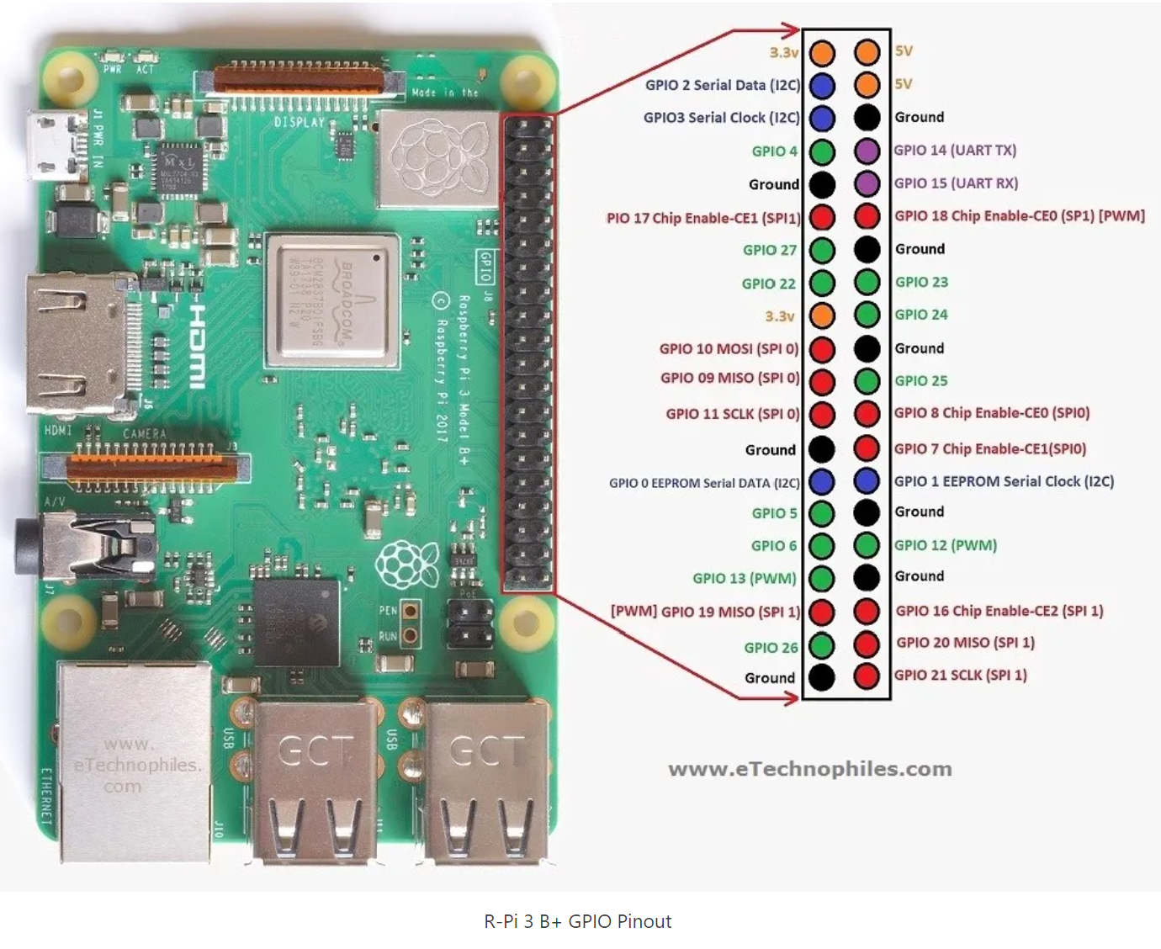

Use ONLY the female end of the LED chain that has 3 wires on the side of the LED that has an arrow, and going into the connector, and 2 loose wires (red and blue) on that same side, i.e. use the end that has what I’ll describe as two squeeze tabs.

* The RED wire is power and should be connected to #2.
* The WHITE wire is data and should be connected to #6.
* The BLUE wire is ground and should be connected to #7.

## Testing the LEDs

Power up the Pi.

Test the LEDs for the four colors used (VFR, MVFR, IFR, LIFR – i.e. green, blue, red, purple) in case there is a bad one. If you find a bad one, don’t panic. You can just skip it by putting NULL in the appropriate row in the airports file later. The easiest way to test this once you’ve installed the software is to manually control the colors of the LEDs by opening the python3 console:

sudo ./metarmap/bin/python

Then enter the following to light up 50 LEDs at once (if you are using a different number, just replace the 50 below):

import board

import neopixel

pixels = neopixel.NeoPixel(board.D18, 50)

pixels.fill((0,255,0))

This will light up all LEDs in red (green for flat WS2812 lights), if you see a bad one, mark it with some tape so you don’t use it for an airport.

Repeat the step for green (red for flat WS2812 lights):

pixels.fill((255,0,0))

Blue (for both types of lights):

pixels.fill((0,0,255))

Purple (for both types of lights):

pixels.fill((0,125,125))

Once you’re done you can turn off the lights by typing

pixels.deinit()

and then press ctrl-Z to exit the python console.

# Configure Application for First Run

How to use an editor on the Pi is beyond the scope of this document. You could edit these files on a PC and then scp them to the Pi if you’re comfortable doing that.

*Edit airports*

*I suggest renaming or deleting the original airports file and simply creating a new one from scratch – it’s easier*. All airports listed in the file must begin with a K. Weather data for airports 11R and 6R3, for example, won’t be found unless you use a leading K! If you’re a ForeFlight user, you can easily validate that a leading K is valid for any airport. In Foreflight Web, hover your mouse over an airport that has weather. If the popup showing the METAR shows a K in the airport identifier, you’re good. However, just because ForeFlight shows a METAR for an airport doesn’t mean it’s valid for this project. The airport must report data to aviationweather.gov.

If you need to leave some LEDs unlit for spacing on your map, or have any bad bulbs you need to skip, simply put a value of NULL in the line for any LEDs you need unlit.

You need to have at least one airport in this file, and no more lines than you have LEDs. Remember that the first LED in the chain (nearest the Pi) corresponds to the first entry in airports, the next entry corresponds to the next LED, and so on. Do not leave any blank lines at the end of the file.

*Edit metar.py*

In our copy of this file, it was line 25 (LED_COUNT) which had to be set to 50, the actual LED count on our string.

If you are using the flat WS2812B LEDs, change this line:

LED_ORDER = neopixel.GRB # Strip type and colour ordering

To this:

LED_ORDER = neopixel.RGB # Strip type and colour ordering

If you think you might at some point use the sunset LED dimming feature, then edit the value for LOCATION in row 66. We set ours to “Houston” vs “Seattle” in the original file. Houston is in the list of cities at <https://astral.readthedocs.io/en/latest/#cities>. This function works great!

The default LED_BRIGHTNESS can vary from 0.0 (unlit) to 1.0 (max). By default, it is set to 0.5. Change to whatever value you like. We used 0.5 for LED_BRIGHTNESS and 0.3 for LED_BRIGHTNESS_DIM. Use .05 and .03 if using the flat WS2812B LEDs.

*Edit pixelsoff.py*

Set # of LEDs in line 8 to the correct value for your LED string.

# GO!

Test the script by running: sudo ./metarmap/bin/python3 metar.py

This is a one-time run of the python script that sets the LED colors. They will remain lit until you either deinit them as described above, run the lightsoff.sh script, or power down the unit. Just doing a Linux shutdown will not turn off the lights.

# Scheduling of Metar Updates and “Lights Off” Time

Details on crontab are beyond the scope of this document. Remember you don’t edit the crontab table directly, but use crontab -e to enter the editor, and can display the contents of the file with crontab -l.

An example crontab file is in the creator’s GitHub repo, but the relevant lines are:

*/5 6-22 * * * /home/pi/refresh.sh

05 23 * * * /home/pi/lightsoff.sh

In this example, the LEDs are refreshed every 5 minutes from 0600 to 2255 every day of the month, for all months, and every day of the week. That is, the refresh script runs from 6 am to 10:55 pm and does not run again until 7 am the next day. The lightsoff script runs once every day of the month, for all months, every day of the week, at 2305 (11:05 pm). If you don’t want to ever turn off the LEDs, simply do not add the entry for the lightsoff script. However, if you do that, you should also modify the entry for the refresh script. If you don’t, then the LEDs will remain lit, but the colors won’t update between 9:55 pm and 7 am! So, to keep them lit and refreshed 24/7/365, you’d delete the lightsoff entry, and change the entry for the refresh script to be:

*/5 * * * * /home/pi/refresh.sh

A nice summary of crontab is at <https://alvinalexander.com/linux/unix-linux-crontab-every-minute-hour-day-syntax>

There was another oddity in the most recent installs. Error messages were showing up in /var/log/syslog:

Aug 12 07:59:01 raspberrypi CRON[1017]: (pi) CMD (/home/pi/refresh.sh)

Aug 12 07:59:01 raspberrypi CRON[1016]: (CRON) info (No MTA installed, discarding output)

MAILTO=””

None of the installs prior to August 11, 2022 showed that error message. It’s harmless but why have it at all? To get rid of that message, add MAILTO=”” as the first line in the crontab after the comments.

# “Animation” for Wind and/or Lightning, and Blinking vs Fading

These are interesting, optional features. Read through the configuration section of metar.py for more info. The word *animation* is used in the code to describe toggling between standard weather condition colors and others for windy, high windy, and lightning conditions.

References to fading in the configuration portion of metar.py don’t imply fading in a traditional sense, i.e. the LEDs won’t gradually fade and then brighten to their original color. Rather, with fading enabled, an LED will alternate between its color and the corresponding fade color level set in metar.py. The alternative to fading is to blink, which means *blinking on and off* vs “fading” to a dimmer color.

I set:

ACTIVATE_WINDCONDITION_ANIMATION = True

ACTIVATE_LIGHTNING_ANIMATION = True

HIGH_WINDS_THRESHOLD = 20

Wind or gusting wind >= WIND_BLINK_THRESHOLD = blink/fade with COLOR_<xx>_FADE

Wind or gusting wind >= HIGH_WINDS_THRESHOLD = blink/fade with COLOR_HIGH_WINDS

## Observations on LED Colors

If you’ve enabled both wind and lightning animations, I have found one combination of conditions where you will not see a standard METAR weather condition color, i.e. won’t see Green, Blue, Red or Purple. If there are both high wind conditions and lightning, your animation will cycle between the color for lightning, and the color for winds at or above the HIGH_WINDS_THRESHOLD.

# Powering Down the Pi

A proper power down procedure would be to run sudo shutdown now, wait 10-20 seconds, then power off the unit. Note that the lights will remain on until you either run the lightsoff.sh script or power off.

Don’t worry about how to start the app after you’ve turned the Pi off, then on again. The crontab entry (or entries) will run automatically at their scheduled times. You need do nothing but power it on. Keep in mind that the lights and display will not activate on startup of the Pi. They are activated/updated every 5 minutes on the clock.

# Getting Your Map Printed

If you don’t want to cut and trim and join folded paper sectionals, then don’t. Get a digital copy of it printed! This is a much cleaner approach and should only cost about $25 for a 16x20 poster print.

Download sectionals at:

<https://www.faa.gov/air_traffic/flight_info/aeronav/digital_products/vfr/>

Here’s a link to a zip to my local (Houston) sectional as a TIF:

<https://aeronav.faa.gov/visual/07-14-2022/sectional-files/Houston.zip>

Ignore the other files in the .zip. You only want the TIF file.

Edit the TIF file to include just the area you want. On Windows, right-click the TIF file in File Explorer, and “open with” Photos. Hit ctrl-E to edit the image. At the bottom center of the screen, click Free to select an aspect ratio of 4:5, which is what you want for a 16x20 poster print. For other sizes, calculate the appropriate aspect ratio. For example, for an 18x24 size, you’d use an aspect ratio of 3:4 (18/24 is .75 or 3/4), and so on. Crop the image, zoom in as needed, move the “box” around to select just the area you want, and in the upper right, select “Save as copy”, then save it under a new name as a JPG.

Don’t try to save too much of the chart in your image. Cramming too much of it into a single image would be zoomed too far out to be usable for this project. My image turned out perfectly. It included the entire area I wanted, and when printed was virtually identical in size to a printed sectional.

For $24.89 out the door, I ordered a 16x20 adhesive poster for same day pickup at Office Depot. The detail and quality of the print was great.

# Optional Color LED Metar Display

## Optional displayairports File

I recommend using this optional file if you use the display. If you don’t, then your display will cycle thru and display every airport in your airports file. I didn’t want it to cycle thru all 21 airports on my map. First, because it appears to cycle thru them randomly, and second, because I only want to cycle thru a short list of those I’m most interested in.

This is a simple text file list. Just make sure the identifiers you put in that file are in fact in your airports file!

## Wire Up Your Display

***Be sure to shutdown and power off the Pi while wiring up the display!***

You will use 4 female-to-female jumper wires for this. When looking at the front of the display, the pins from left to right are Ground, Power, SCL and SDA. These go to pins 9, 2, 5 and 3 on the Pi as shown below.

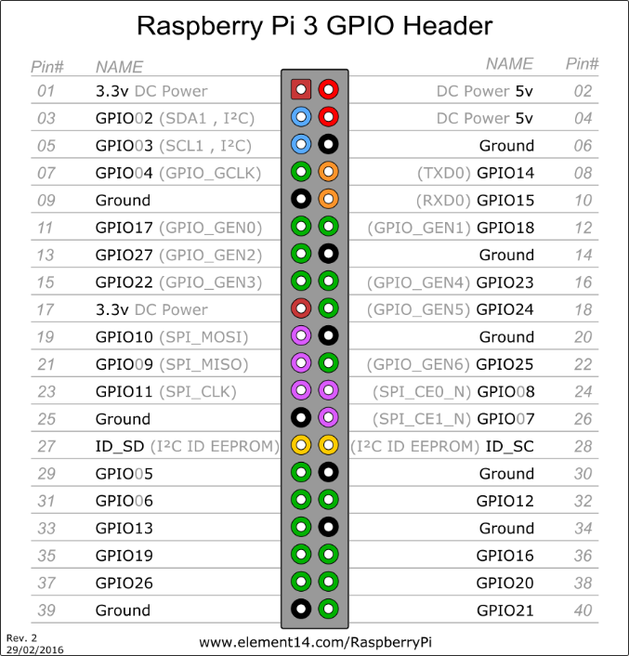

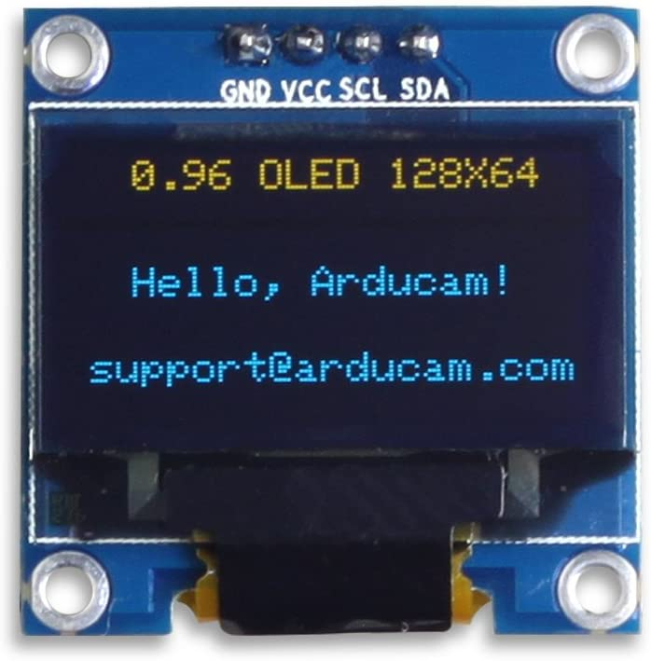

## Testing the Display

Power up the unit and run sudo i2cdetect -y 1. The output of this command should show something connected at 3C, as shown below. This command will not put anything on the display itself. It merely confirms that the system detects it as present.

0 1 2 3 4 5 6 7 8 9 a b c d e f

00: -- -- -- -- -- -- -- --

10: -- -- -- -- -- -- -- -- -- -- -- -- -- -- -- --

20: -- -- -- -- -- -- -- -- -- -- -- -- -- -- -- --

30: -- -- -- -- -- -- -- -- -- -- -- -- 3c -- -- --

40: -- -- -- -- -- -- -- -- -- -- -- -- -- -- -- --

50: -- -- -- -- -- -- -- -- -- -- -- -- -- -- -- --

60: -- -- -- -- -- -- -- -- -- -- -- -- -- -- -- --

70: -- -- -- -- -- -- -- --

*Configuring metar.py to Run the Display*

Set the ACTIVATE_EXTERNAL_METAR_DISPLAY parameter to True. *Note that if you ever disconnect the display, be sure to change this parameter back to False*. If not, and the display has an issue or is disconnected, the LEDs will not light up. Rather, the program will throw an error and exit, doing nothing at all.

If you wish to change the default time that single airport’s METAR is displayed, change the DISPLAY_ROTATION_SPEED parameter.

I made these edits while the cronjob was running, and at the next run interval, the display came alive for the first time!

## Modified displaymetar.py Script for Alternate Display Text

For a simplified display and larger text, replace the original displaymetar.py script with this one. The first row of text on the display will be <airport code>-<flight category>. The second row of text will be <wind direction>@<speed>, followed by G<gust speed> if applicable.



# Construction – Finally!

Identify in advance all airports on your chart that report weather to aviationweather.gov, and which you will want represented by an LED. I used SkyVector to do the layout (<https://skyvector.com>). A picture of the final layout is shown later in this document.

Glue 2 foam boards together by spraying one side of each with adhesive and pressing together. You won’t be able to reposition these much once they contact each other, so be careful. If you spray both boards, you likely won’t be able to reposition them at all.

Attach your sectional print to the foam board with two bull dog clips at top and two at bottom. Use parts of an index card or thick paper between the sectional and the clip to avoid marking or cutting the sectional. Keeping the chart precisely positioned throughout this process is important.

Put a push pin thru the center of each airport’s symbol, exactly where you want the LED light to show.

Unclip either the top or bottom of the sectional and gently curl it out of the way so you can drill thru the foam and not the map.

Drill a 1/8” pilot hole thru each push pin hole and both foam boards, then enlarge them with the 9/32” bit.

Clip both ends of sectional chart to the foam boards. Do not glue the chart to the boards yet.

From the rear of boards, lay out all the LEDs, skipping some as needed for spacing. Identify the area on the back of the board where you will mount your Pi, and your display if you’re using one. Start the LED string as close to the Pi as possible. You don’t want to put the Pi or display close to an airport LED. If you are using the optional OLED display, you’ll want to place the Pi relatively close to where you will install it, as the jumpers won’t reach very far.

Insert LEDs temporarily into each hole. Identify which airport corresponds to each hole…write it down on the back of the board. You’ll need this information to set up your airports file.

Remove clips from one end of the sectional and curl it out of the way. Ream each hole in the foam board to remove as much of the raggedness as you can. At least have any ragged ends pushed against the outer edge of the hole as much as possible. For any particularly messy holes, you can use a soldering iron to gently burn off material.

On the front of the board, put a small piece of black duck tape over each hole, maybe 1” square. The idea is to block light from blooming beyond the small opening you will create in the chart itself. This will create a nice pinpoint of light from each LED thru the sectional. Large pieces of tape don’t matter, but you must cover the 9/32 hole completely. Smooth the edges of the tape so the entirety of the sectional will lay as flat as possible.

Spray the bottom front of the board with adhesive, and carefully lay down that half of the sectional. Be sure to maintain alignment!

Now remove the clips from the top of the board, lift off that half of the sectional, spray that top half of the board with adhesive, and lay down and smooth that part of the sectional.

Use the 1/8” center punch to punch thru each push pin hole in the sectional penetrating the black duck tape underneath it. Carefully ream or clean up each hole, but don’t enlarge it. Don’t use a drill for this step as it will leave ragged tears/edges. A punch is much preferred.

While this next step is optional, it results in very clean, uniformly rounded holes in the front of the map. Take your soldering iron, with a round or flat tip, and gently insert from the front of the map, through the map perhaps 1/8”. It only needs to penetrate thru the duck tape.

Now hot glue the LEDs onto the back of the board, being sure to maintain the order from the earlier step. Be generous with the hot glue!

Use Velcro strips to attach the Pi to the back of the board, power it up, set up your crontab if you haven’t already, put your airports file (and if using the display, the optional displayairports file) in place, and enjoy.

The placement of the OLED display in the sectional is dependent on your particular sectional. That won’t be covered here. Neither will framing.

The airports file we used is below, where the word “NULL” indicates a skipped LED:

KGLS

NULL

KT41

KEFD

KHOU

KLVJ

KAXH

KSGR

NULL

KLBX

NULL

KBYY

NULL

KARM

NULL

KELA

NULL

KTME

NULL

KDWH

KIAH

NULL

KT78

NULL

K6R3

NULL

KCXO

NULL

KUTS

NULL

NULL

KCFD

KCLL

NULL

K11R

The LED layout for our particular project, created on SkyVector, covering the greater Houston area, is shown below. The LED string started with Galveston (KGLS) at the lower right and ended with Brenham (K11R) near the top left.

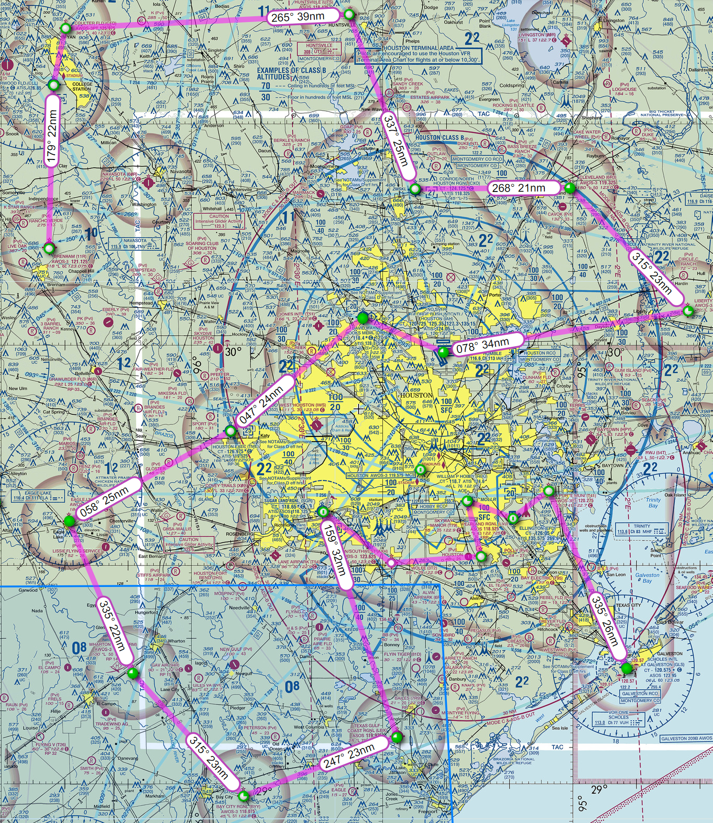

A talented friend made up custom frames with glass. Here’s the result. The Pi was attached on the back of the assembly near the OLED display. The display was placed in an area that wouldn’t cover any meaningful area of the chart.

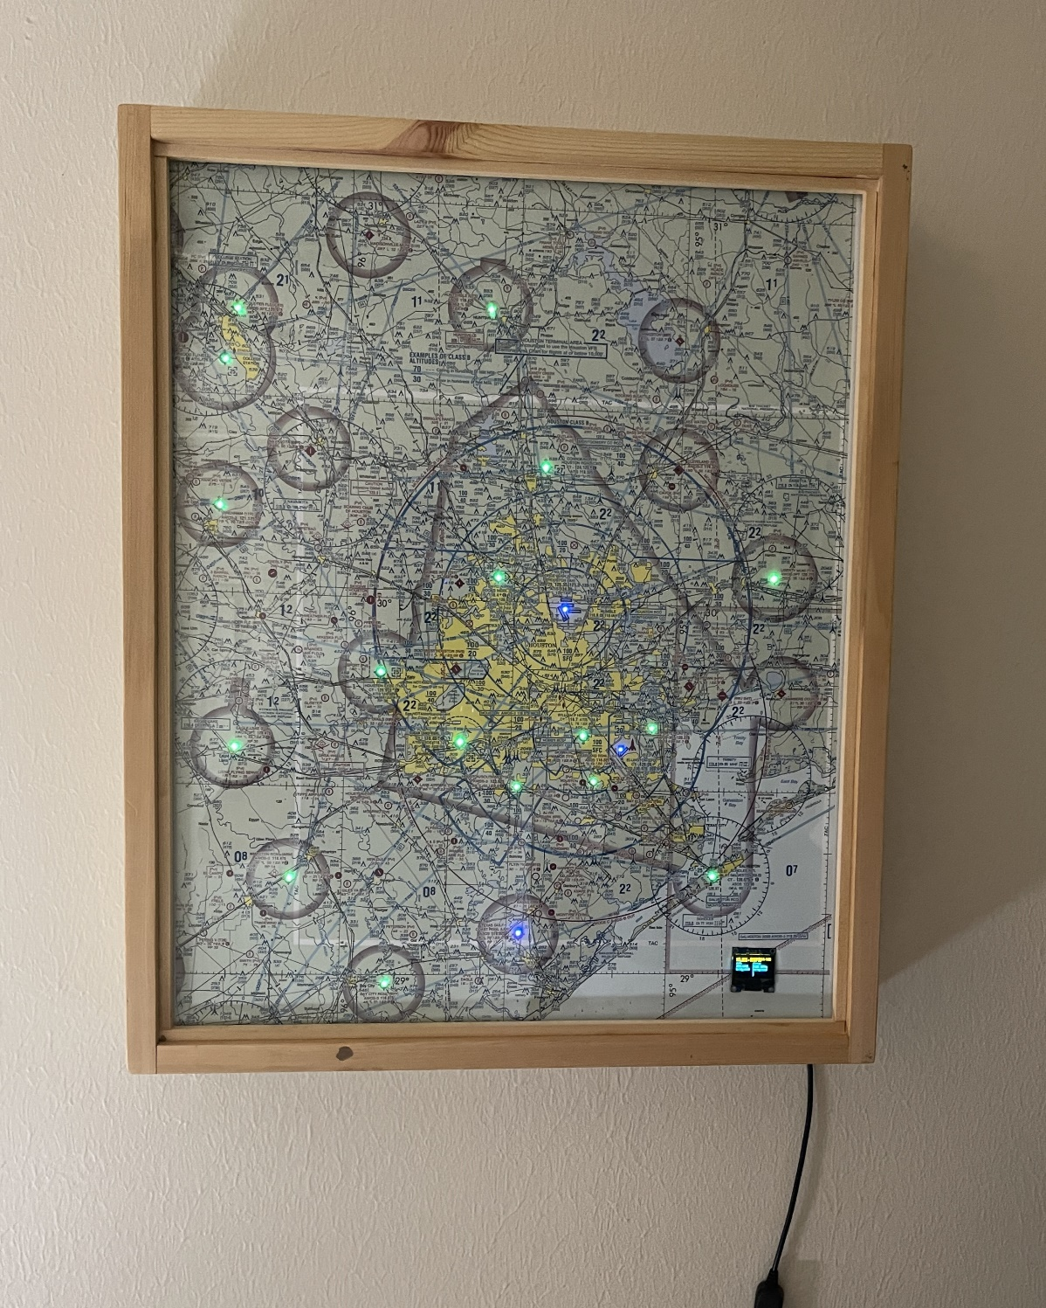

# Alternate Build with WS2812B Flat LEDs

After building four of these maps, I looked for a way to reduce its depth. The WS2811 LED bulbs in the parts list are sturdy and easy to work with, but they add depth to the project. One way to reduce that depth is to use flat LEDs, which then allows you to use only one foam board vs two since the flat LEDs have almost zero depth and do not need to be anchored in a deep hole. The total depth of the project using this type of build is 1 1/8” inches, including the Pi Zero W in a case. This shallower depth permits use of a standard 2” deep shadow box.

The only flat LEDs I recommend currently ship from AliExpress in China. My set took two weeks to arrive. For my particular map, each of these strings was enough to make two maps.

WS2812B DC5V 22mm diameter round pixel light,DC5V input(5050 smd RGB led with WS2811IC built-in), $7 plus shipping, string of 50 lights

<https://www.aliexpress.us/item/2251800954774376.html?spm=a2g0o.productlist.main.1.68514279T2cK79&algo_pvid=3e9a60ca-4888-4a41-a6f8-6557a5605f99&algo_exp_id=3e9a60ca-4888-4a41-a6f8-6557a5605f99-0&pdp_npi=3%40dis%21USD%217.0%217.0%21%21%21%21%21%40211bea0816834691617383051d07b9%2112630401719%21sea%21US%214563208766&curPageLogUid=1l6QVXirsdB5>

These are pre-wired and require no soldering, like some others I experimented with. Do yourself a big favor and don’t use the LEDs that require soldering!

Follow the same technique described previously to physically build the map but use only one foam board vs two.

